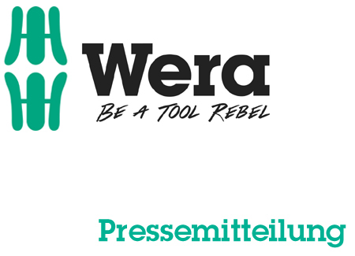

Date: 06 March 2016
Editor: Klaus Teders

Grab attention at the point of sale!

New design Wera screwdriver display

Supporting the specialised trade with advertising media / New display design inspired by award-winning packaging design / Modular concept: display a selection of one or multiple products / Top board for two screwdriver sets /

Cologne / Wuppertal. It is Wera company strategy to support the B2B trade with a whole range of advertising media for product presentation. This includes displays that can hold a wide variety of tools available from the Wuppertal manufacturer, to be used at point of sale.

Goliath! Or a screwdriver display…?
Wera has launched an interesting new screwdriver set display at the 2016 Cologne Hardware Fair; it’s design inspired by the new, award-winning packaging design now used by the specialist manufacturer to box the majority of its products. In fact, it does look rather like a screwdriver set box…of giant proportions!

For those who do not wish to make a commitment…
This versatile new display is particularly flexible in use, being able to accommodate a wide variety of Wera screwdriver sets, with their variety of box sizes. The display is not locked into one specific range, so it can be equipped with a quantity of either a single product or selection of complementary sets. The top board accommodates two of the sets that are held in the display below, so it is clear from a distance exactly what products are featured.

The new screwdriver display can be ordered from Wera with either a set configuration of included screwdriver sets, or empty – for individual assembly and customisation.

More information:

Wera Werk Hermann Werner GmbH & Co. KG

Korzerter Straße 21-25, 42349 Wuppertal / Germany

Phone: +49 (0)2 02 / 40 45 311, Fax: 40 36 34

e-Mail: info@wera.de, Internet: www.wera.de

Wera Tools (UK) Ltd

Units 1-2 McGregors Way, Turnoaks Business Park,

Chesterfield. S40 2WB

Tel: 01246 277756 Fax: 01246 273335

email: queries@wera-tools.co.uk web: www.wera-tools.co.uk

Search @WeraToolsUK on Social Media

TECHNO PRESS
Caption:

01_Wera_Display
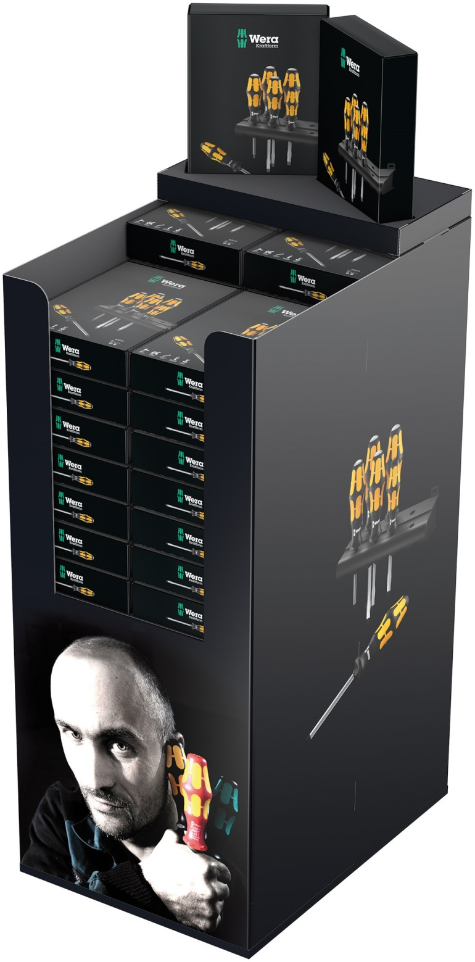
Ths new display for the presentation of various Wera screwdriver sets at the point of sale corresponds to the design of the award-winning packaging concept.

Picture: Wera Werk Hermann Werner GmbH & Co. KG

Press contact:

Wera Werk  Hermann Werner GmbH & Co. KG  Detlef Seyfarth  Korzerter Straße 21-25  42349 Wuppertal / Germany  Phone: +49 (0)2 02 / 40 45 311  Fax: +49 (0)2 02 / 40 36 34  e-Mail: info@wera.de | TECHNO PRESS  Presseinformationsdienst  (Press Information Service)  Wolfgang D. Riedel  P. O. Box 10 04 49  42004 Wuppertal / Germany  Phone: +49 (0)2 02 / 9 70 10 0  Fax: +49 (0)2 02 / 9 70 10 50  e-Mail: info@technopress.de
Released for printout, copy requested

